ITM 440/540 - Data Networks

Assignment 6

Assigned: 10/07/2014 Due: 10/12/2014

Name: _______________________________________________________

Student ID: __________________________________________________

Purpose: Practice concepts related to the MAC address and LAN connecting devices.
MAC Addresses:

1. If an Ethernet destination address is 06:01:02:04:05:07, what is the type of the address (unicast, multicast or broadcast) ? unicast ____________________________

2. If an Ethernet Destination Address is 57:7N:6C:DE:10:00, what is the type of the address (unicast, multicast or broadcast)? multicast ______________________

3. A networked computer receives a frame with the Source Address 57:7N:6C:DE:10:00.
The computer discards the frame. Why?

The address is a multicast address and a multicast address cannot be the source of a frame. _____________________________________________________________

4. If an Ethernet Destination Address is ff:ff:ff:ff:ff:ff, what is the type of the address (unicast, multicast or broadcast)? broadcast ______________________

5. What is the access control method that is used on Ethernet II and IEEE 802.3 LANs?

CDMA/CD or Carrier Sensed Multiple Access with Collision Detection ___________

6. The minimum length of an Ethernet II frame is 64 ___________ bytes.

7. The minimum length of an IEEE 802.3 frame is 64 ___________ bytes.

8. The minimum length of the body of an Ethernet II frame is 46 ____________ bytes.

9. The minimum length of the body of an IEEE 802.3 frame is 38 ___________ bytes.

10. Ethernet II receives 42 bytes of data from layer 3. How many bytes of padding must it add to the data before it hands it to layer 1 to be put onto the channel? ___4 bytes

11. What is the maximum length that an Ethernet II Frame can have? ____ 1518 bytes

a. How many of those bytes are in the header? 14 bytes ___________________

b. How many of those bytes are in the trailer? 4 bytes _____________________

12. Ethernet II receives 1510 bytes of data from layer 3.

a. How many bytes of header does the Ethernet II Process need to add to this data? 14 _________ bytes.

b. The resulting frame would be how long? 1524 ____________ bytes.

c. Can the Ethernet II process put such a frame onto the LAN? Explain your answer.

No. The maximum frame length of an Ethernet II LAN is 1518 bytes.

13. How much time is required to send 64 bytes on an Ethernet II LAN?
Note 1: Assume the bit rate is 10 Megabits per second == 10x10⁶ bits/second
Note 2: You are asked for a time, so the units of the answer will be seconds.

64 bytes x 8 bits/byte / 10x10⁶ bits/second == 51.2 x 10⁻⁶ seconds _________

14. How many meters can the 64 bytes in problem 14 travel if the propagation speed for a signal is 2x10⁸ meters/second? (Hint: Multiply the propagation speed by the time in seconds you calculated in problem 14.)

51.2 x 10⁻⁶ seconds x 2x10⁸ meters/second == 102.4 x 10² meters == 10,240 meters _______________________________

15. Explain the difference between a repeater and an amplifier?

An amplifier is an analog device that multiplies the amplitude of the signal it receives to make it larger. A repeater is a digital device that detects an incoming signal, and re-creates that signal. It does not multiply the amplitude of the incoming signal. ______________________________________________________________________

<Question 16 – 23 on next pages>

Use Figure 1 below (Figure 15.5 in the textbook) to answer the questions that follow. There are two drawing in Figure 1. Use the one on the bottom and the Bridge Table to answer the questions. The diagram at the top is what I have called a ‘sandwich diagram.’ It is designed to remind you that the bridge operates at layers 1 and 2 only. Higher layers of the protocol stack ‘flow’ right over the bridge. The bridge does not read the information in layer 3 or above.

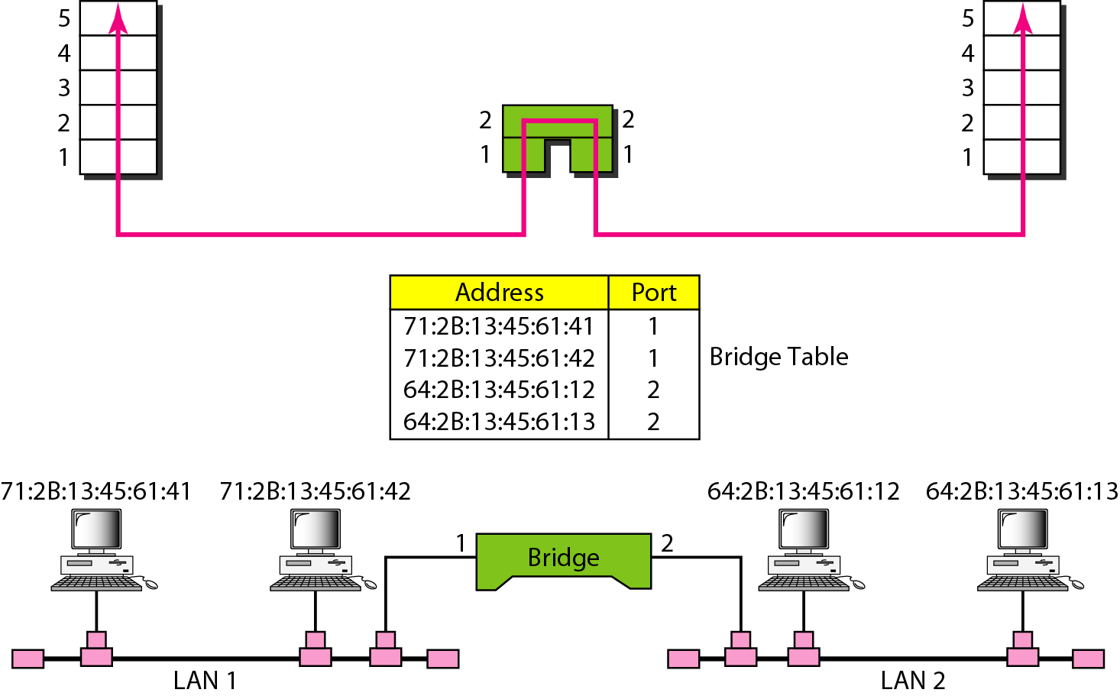

Figure 1.

16. A frame with the Destination Address 71:2B:13:45:61:41 arrives at Port 1 of the bridge. Does the bridge forward this frame or filter it?

It filters the frame because it sees that the destination address is on LAN 1 which is connected to port 1. _________________________________________________

17. A frame with the Destination Address 64:2B:13:45:61:12 arrives at Port 1 of the bridge. Does the bridge forward this frame or filter it?

It forwards the frame because it sees that the destination address is on LAN 2 which is connected to port 2. ___________________________________________________

18. What layer of the IP Data Communication Model does a Hub operate at?

Layer 1 ________________________________________________

19. What layer of the IP Data Communication Model does a Bridge operate at?

Layer 2 ________________________________________________

20. What layer of the IP Data Communication Model does a switch operate at?

Layer 2 ________________________________________________

21. Which device forwards frames using a forwarding table that shows the port at which the destination MAC address is connected? B ___________________________
a) Hub b) Switch c) Router

22. Which device forwards datagrams using a routing table that shows the interface through which the datagram must travel to reach the destination IP address? C ___________________________________________________________________
a) Hub b) Switch c) Router

23. Which device is a collision domain which does not forward frames or datagrams?
A ________________________________________________________________
a) Hub b) Switch c) Router

